COLD ASHBY VILLAGE (memorial) HALL
Main Street, Cold Ashby NN6 6EL
Charity number 1024816
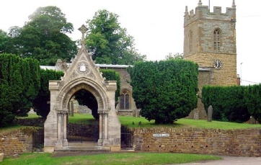
Annual General Meeting 2020-2021

Wednesday 16th November 2021 at 7.30 Village Hall

Minutes

1.The chairman, Mr R Bailey, took the chair.
2. Attendance: 19 people attended including 7 current committee members.
3. Apologies: received from committee member Fiona Gunn-Stokes, who had indicated a willingness to stand for office if nominated.
4. Minutes of the 2019-20 AGM (held in June 21) were approved.
5. Matters arising from the minutes: none
6. Chairman's report. The chairman gave a report on the actions of the existing committee to secure the future of the village hall and welcomed the larger attendance at the AGM and the emergence of new committee volunteers. He announced the retirement of the secretary/treasurer and indicated his own wish to retire from office as soon as practicable.
7. secretary/treasurer's report; The secretary treasurer presented figures which were accepted as an accurate record by the meeting.
8. The accounts for year 2019/2020 were unanimously adopted.
9. To elect a committee in accordance with the trust deed to act until the next annual general meeting. The chairman explained the constitution of the committee and that then officers would be elected by the committee at a meeting to follow the AGM.
10. Four elected members: F Gunn-Stokes, K Stuart, A Bott and T Thompson were elected as village representatives. Members nominated by The Bowls Club, The Parish Council and the Parochial Church Council and the Others as appropriate (i.e., Friendly/Luncheon Club) would continue and fresh nominations sought later in the year.
11. Programme of meetings until the November 22 AGM. This was deferred until the committee meeting.

G Jones, Secretary November 21

